**COLABS : An Office Blog**

**Introduction:**

* Typically, in an office, announcements, deadlines or meetings are usually posted

using sticky notes.

* This project is an effort to create an interactive office communication platform for real time team communications.

**Objective:**

* Office employees can make announcements, post deadlines, interact with other colleagues through threaded comments.
* Logged user can create, edit and publish posts that can be used for any above-mentioned purposes.
* Authenticated users can create private draft applications, which can be published anytime.

**Database Description:**

* 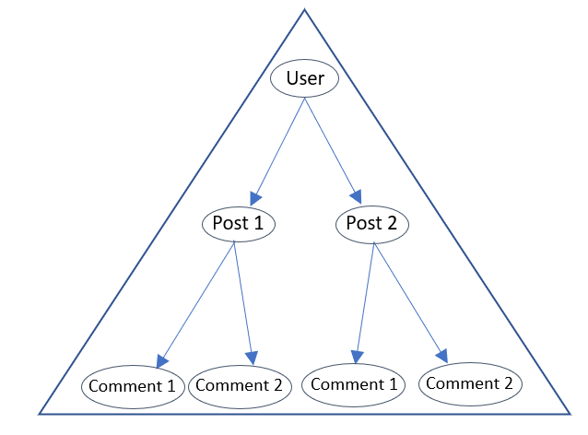User Table:
* username, email, password
* Post Table:
* Foreign_key - **User** (many-to-one relationship)
* author, title, text, created_date, published_date
* Comments Table:
  + Foreign_key - **Post** (many-to-one relationship)
  + author, text, created_date, approved_comments
* Contact Table:
  + email, subject, message

**Submitted by:** Rajat P - 01JST20IS031

Prabhat - 01JST20IS033

Priyanshu - 01JST20IS034

Shashank - 01JST20IS041